**WEB X Lab Exp 2**

K Suryanarayan Dora Vu4f2122034 Div: A Batch: B

**Aim:** Study Semantic Web Open Source Tools like Apache Tinkerpop.

Introduction :

Semantic Web Analytics is the analysis of a website’s traffic done using named entities and related vocabularies such as schema.org.With this analysis, you can start from the website’s structured data and cross-reference it with data from Google Analytics, Google Search Console, or other CRM. In this way, you can learn more about user and customer behavior and gain a competitive advantage beyond just analyzing impressions and traffic.

Apache TinkerPop is an open-source graph computing framework that provides a set of specifications and implementations for working with graph databases and graph processing systems. It is part of the Apache Software Foundation and aims to standardize the process of interacting with graph databases using a common language and set of APIs (Application Programming Interfaces).

TinkerPop is widely used in applications that involve graph data, such as social networks, recommendation engines, fraud detection, network analysis, and more. By providing a common framework, TinkerPop enables developers to work with different graph databases without being tightly bound to a specific implementation, fostering interoperability and standardization in the graph computing space.

Features

* Graph Database Abstraction:

TinkerPop abstracts the underlying details of different graph databases, allowing developers to interact with various graph databases using a unified set of interfaces and query language.

* Gremlin Query Language:

Gremlin is a graph traversal language that comes with TinkerPop. It allows users to traverse and manipulate graphs in a vendor-neutral manner.

Gremlin is both human-readable and machine-readable, making it versatile for querying and manipulating graph data.

* Graph Processing:

TinkerPop provides a framework for graph processing, allowing developers to execute complex computations on large-scale graphs. This includes algorithms for pathfinding, pattern matching, and graph analytics.

* Vertex-Centric Programming Model:

TinkerPop follows a vertex-centric programming model, which means that graph computations are expressed in terms of the vertices of the graph. This model simplifies the development of graph algorithms and queries.

* Graph Databases and Backends:

TinkerPop supports various graph databases and backends, including popular ones like Apache Cassandra, Apache HBase, Amazon DynamoDB, and more. This flexibility allows developers to choose the underlying storage system that best fits their needs.

* Extensible Framework:

TinkerPop is designed to be extensible, allowing developers to add custom graph algorithms, serializers, and other components to suit their specific requirements.

* Community and Ecosystem:

TinkerPop has a growing community of users and contributors. The ecosystem includes various tools and projects that leverage TinkerPop for graph-related tasks.

Audience

Apache TinkerPop, being a graph computing framework, is primarily targeted at developers and organizations working with graph databases and graph processing systems. The audience for Apache TinkerPop includes:

* Data Engineers:

Data engineers responsible for designing and implementing data architectures that involve graph databases. Professionals working on the integration of graph data with other data processing and storage systems.

* Graph Database Users:

Users and administrators of graph databases that support TinkerPop, such as Apache Cassandra, Amazon Neptune, or others. Those looking to develop custom graph algorithms and applications using TinkerPop on top of their chosen graph database.

* Researchers and Data Scientists:

Researchers and data scientists working on projects that involve graph analytics, social network analysis, recommendation systems, or any application where graph data is a key component.

* System Architects:

System architects designing distributed systems that involve graph processing and require scalable solutions.

* Open Source Enthusiasts:

Individuals and organizations interested in contributing to or extending the capabilities of an open-source project. TinkerPop's extensible nature makes it appealing to those who want to actively participate in its development.

* Enterprises and Organizations:

Businesses and organizations looking for a standardized way to interact with various graph databases and build applications that leverage graph data. Enterprises interested in developing or optimizing applications related to social networks, fraud detection, recommendation engines, or any scenario where a graph-based approach is beneficial.

It's important to note that TinkerPop is a versatile framework that can be used in various industries and domains. Its flexibility and support for multiple graph databases make it suitable for a broad audience interested in graph computing. Users typically interact with TinkerPop through the Gremlin query language and leverage its APIs to build applications that involve graph data and computations.

Comparison:

TinkerPop is well-suited for graph computing use cases, including social networks, recommendation systems, and graph analytics. Semantic analytics tools may be more suitable for applications where explicit representation of semantics and reasoning are crucial, such as in knowledge graphs.

TinkerPop primarily deals with property graphs, while semantic analytics tools work with RDF data models. The choice may depend on the nature of the data and the requirements of the application.

Both TinkerPop and semantic analytics tools may have active communities and ecosystems, with various tools and libraries that complement their functionalities

TinkerPop aims for interoperability across different graph databases. Semantic analytics tools may focus on interoperability within the realm of semantic web technologies.

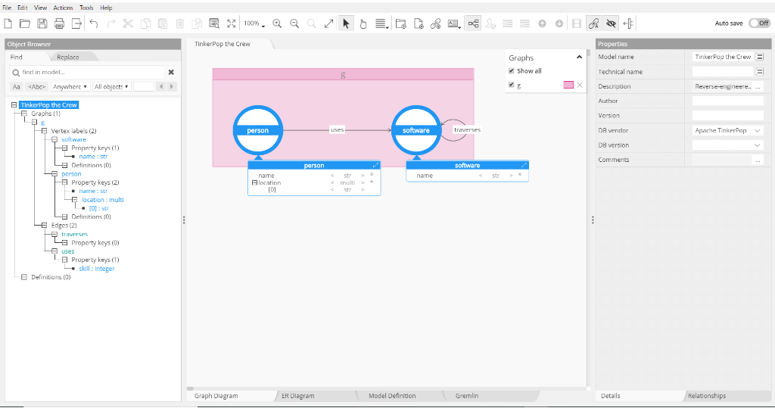

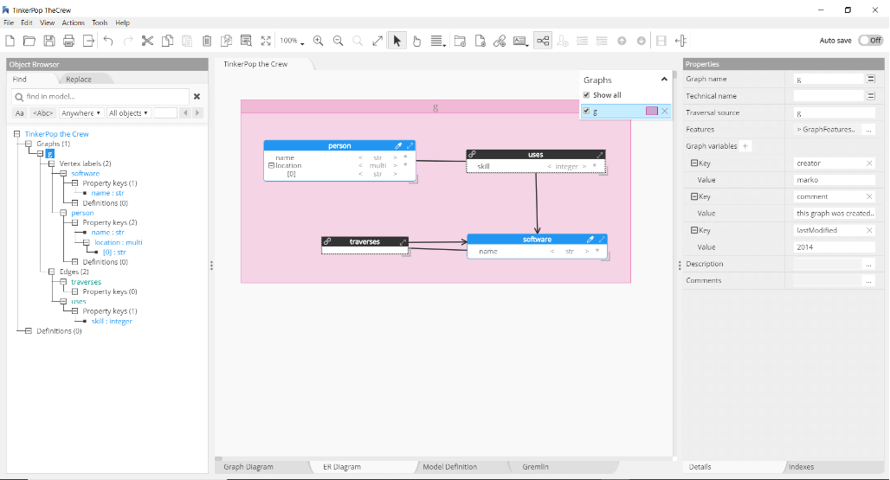

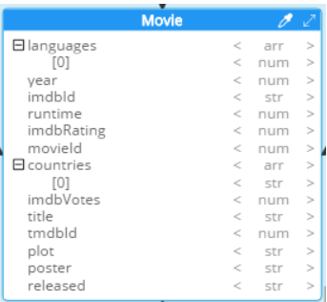

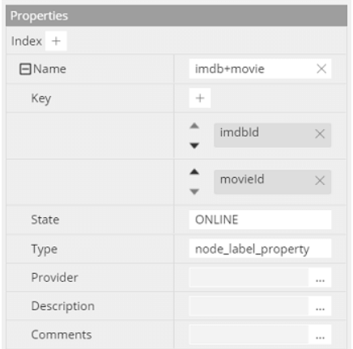

Conclusion: Thus we have successfully studied semantic web open source tool – Apache Tinkerpop.